Birthday reminder﻿
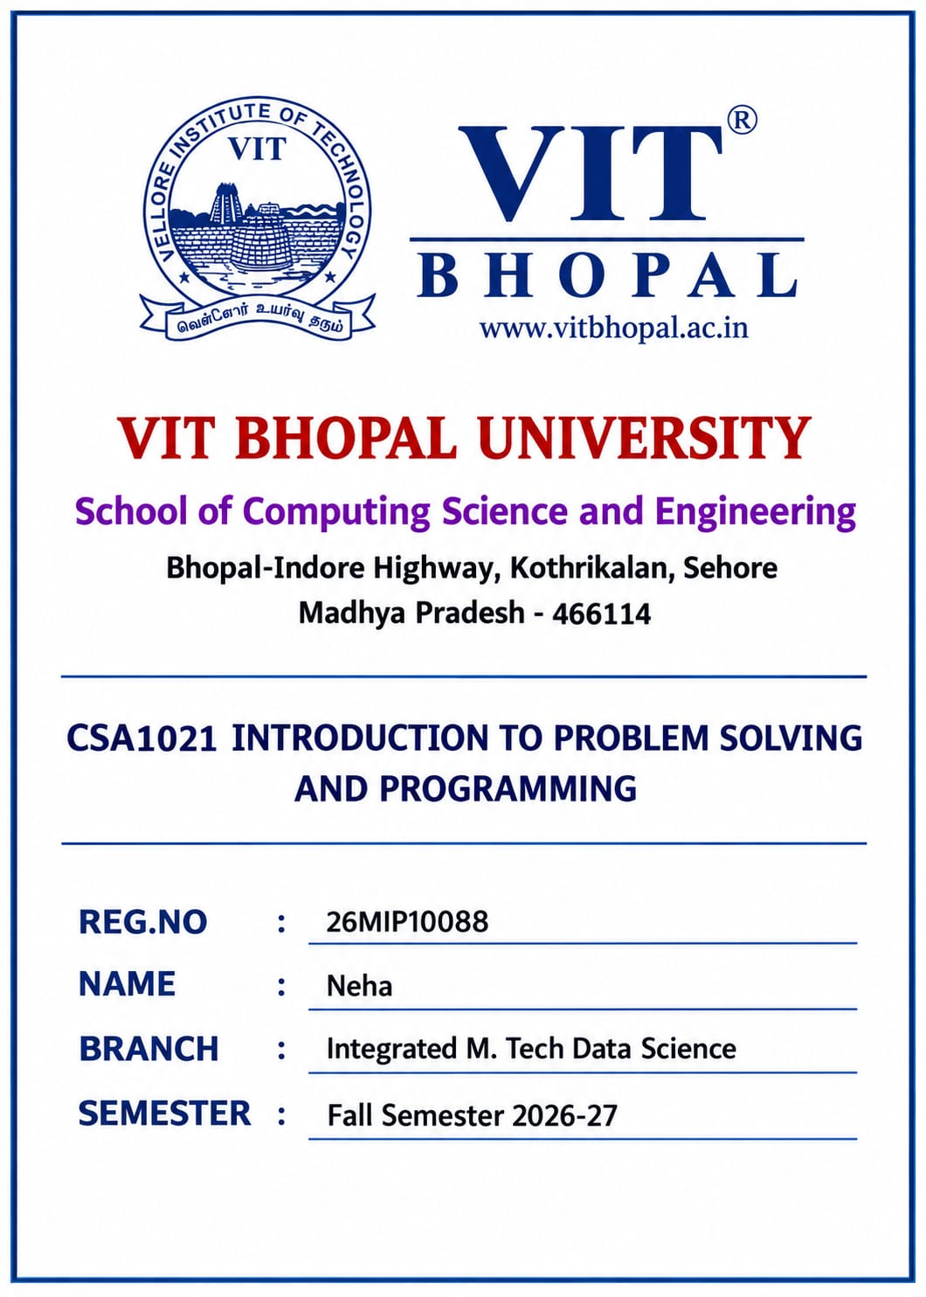
BIRTHDAY REMINDER SYSTEM﻿
- Introduction
Birthday Reminder System is a simple Python application that helps users remember their birthday. The program takes the user's name and date of birth only once. It checks the current date and displays a birthday reminder.﻿
- Objective
- To create a simple birthday reminder using Python.
- To check whether the birthday is today.
- To calculate the days remaining for the next birthday.
- To practice Python date and time operations.
- To automatically stop the program after execution.
- Technologies Used
- Language: Python
- Module: datetime
- Platform: Python IDLE / VS Code
- Requirements
Hardware: Computer/Laptop, Keyboard, Monitor﻿
Software: Python 3.x﻿
- Working
- The program starts.
- The user enters their name.
- The user enters their birthday in DD-MM-YYYY format.
- The program gets today's date.
- It compares the birthday with today's date.
- If the birthday is today, a birthday message is displayed.
- Otherwise, the remaining days are calculated.
- The program displays the result and automatically stops.
- Algorithm
- Start.
- Import "datetime".
- Enter name and birthday.
- Convert birthday into date format.
- Get the current date.
- Compare both dates.
- Display the appropriate reminder.
- Calculate remaining days if required.
- Stop.
- FlowchartSTART ↓Enter Name↓Enter Birthday↓Validate Date↓Get Today's Date↓Compare Birthday↙ ↘Same? Not Same↓ ↓Happy Birthday CalculateDays Left↘ ↙Display Result↓STOP
- Main Python Concepts
- Variables
- "input()"
- "if-else"
- "try-except"
- Functions
- "datetime" module
- Date calculation
- Sample Input
Enter your name: NehaEnter your birthday (DD-MM-YYYY): 30-09-2006﻿
- Sample Output
Name: NehaBirthday: 30-09-2006﻿
Your birthday is not today.Days left: 3Next Birthday: 30-09-2026﻿
PROGRAM STOPPED SUCCESSFULLY﻿
- Advantages
- Simple and easy to use.
- Requires only one-time input.
- Automatically calculates remaining days.
- Automatically stops after execution.
- Future Scope
The project can be improved by adding multiple users, permanent data storage, email notifications, mobile notifications, and a graphical user interface.﻿
- Conclusion
The Birthday Reminder System is a simple Python project that demonstrates the use of input, conditional statements, exception handling, and the "datetime" module. It provides a quick birthday reminder and automatically stops after completing its task.﻿
- References
- Python Documentation
- Python "datetime" Module
- Basic Python Programming Concepts

